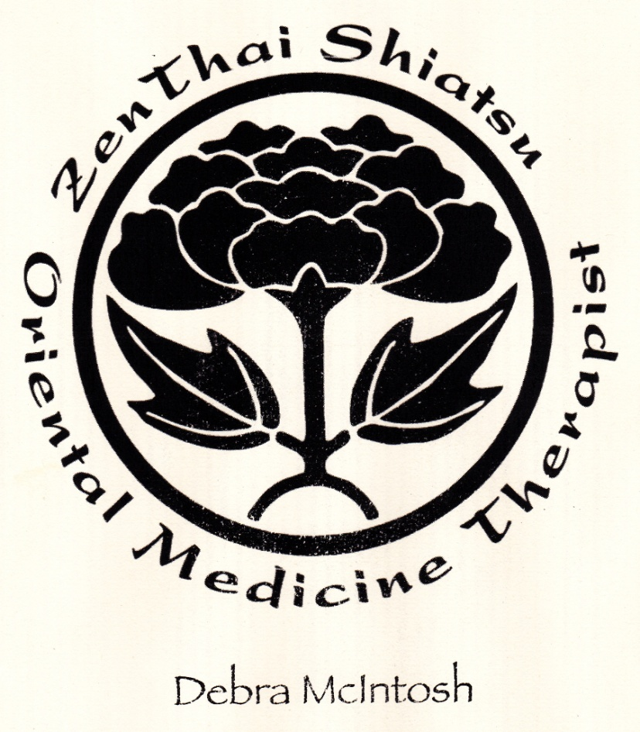ORIENTAL THERAPY 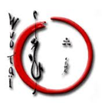
Zenthai Shiatsu -is an Oriental fusion of traditional Shiatsu, Thai & Chinese Massage with Osteopathic techniques & remedial therapy that open the meridian lines & acupressure points connected to the bodies organs. It stretches the muscles, bones & connective tissues, bringing about new life force energy, harmony & alignment. Diagnosis, Cupping & Moxabustion may be included in any given treatment.
Wuo Tai ®-is a new & unique Osteo Danse form of bodywork that unravels the soft and dense connective tissues. By moving between 2 circles. The circular motion brings support and flexibility deep within the myo-facial chains that communicate subtle vibrations to the whole body systems and their functionality.
ZENTHAI SHIATSU & WUO TAI® 1 hr/$70 1.5 hrs/$110 2 hrs/$140
Diagnosis, Cupping & Moxabustion

Reflexology & Thai Foot Massage ½ hr/$35 1 hr/$60

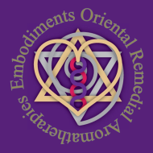 Please note all fortnightly bookings receive a $10 discount

